MAWLANA BHASHANI SCIENCE AND TECHNOLOGY UNIVERSITY
SANTOSH, TANGAIL-1902



DEPARTMENT OF INFORMATION AND COMMUNICATION TECHNOLOGY
Lab Report

Lab Report No : 01
Lab Report on : Design and Deployment of a Personal Portfolio by using Google Site
Course Title : Web Application Development Lab
Course Code : ICT-3204

Submitted By | Submitted To
Name: Kuldip Saha Mugdha  ID: IT-22018  3rd Year, 2nd Semester  Session: 2021-2022  Dept. of ICT, MBSTU | Mr. Md. Anowar Kabir  Lecturer  DEPARTMENT OF INFORMATION AND COMMUNICATION TECHNOLOGY  MAWLANA BHASHANI SCIENCE AND TECHNOLOGY UNIVERSITY

Date of Performance: 23/10/25 Date of Submission: 31/10/25
Introduction:
In the digital era, having an online presence is essential for personal and professional growth. This lab report documents the process of designing and publishing a personal portfolio using Google Sites. Through this project, I explored web design basics, content organization, and digital presentation—all without the need for advanced coding skills.

Objectives:
- To create a personal portfolio website using Google Sites.
- To present academic, professional, and personal information in an organized and visually appealing format.
- To develop a platform that can be shared with teachers, employers, and others for showcasing achievements and skills.
- To explore and apply basic website design principles without using code.

Working Principle:
- Accessing Google Sites:
I began by logging into my Google account and navigating to Google Sites. From there, I initiated a new project and selected a clean, professional template as the base design for my portfolio.

- Customizing the Template:
Using the built-in editor, I followed the style of the chosen template but customized each section to suit my personal content. I adjusted the layout, colors, fonts, and headers to give the site a unique and consistent appearance.

- Creating the Navigation Bar :
Organized the site using a navigation bar with the following sections:
About , Resume , Research & Projects

- Developing the “Home” Page:
In this section, I introduced myself and overview of my career. And also add a contact button.

➢ Visual Overview of the “Home” Page:
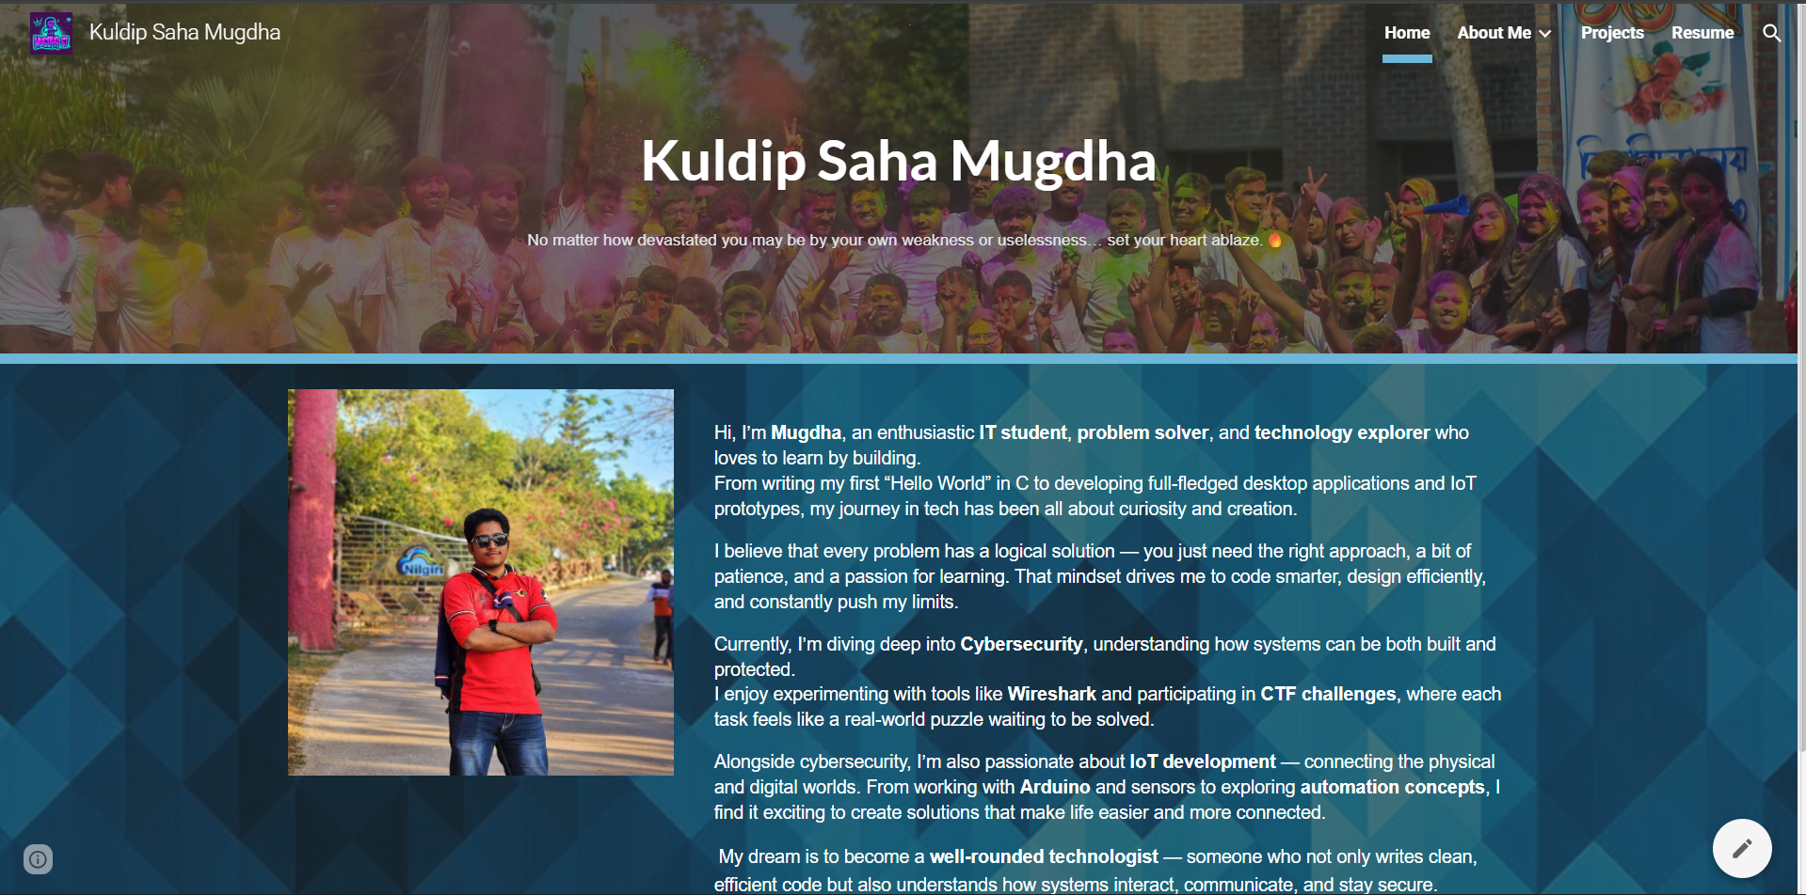
Fig 01: Home Section

- Developing the “About Me” Page:
In this section, I introduced myself, described my academic background, highlighted my technical skills, and my achievements.
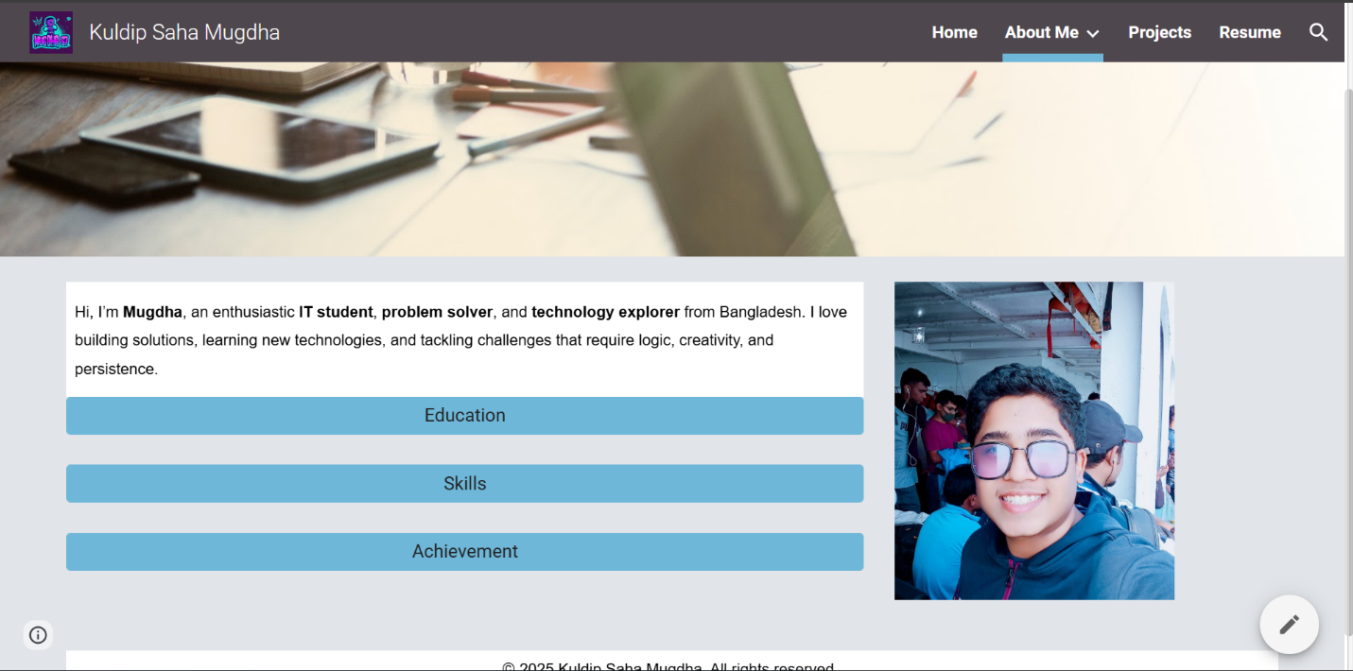
➢ Visual Overview of the “About” Page:

Fig 02: About Me Section
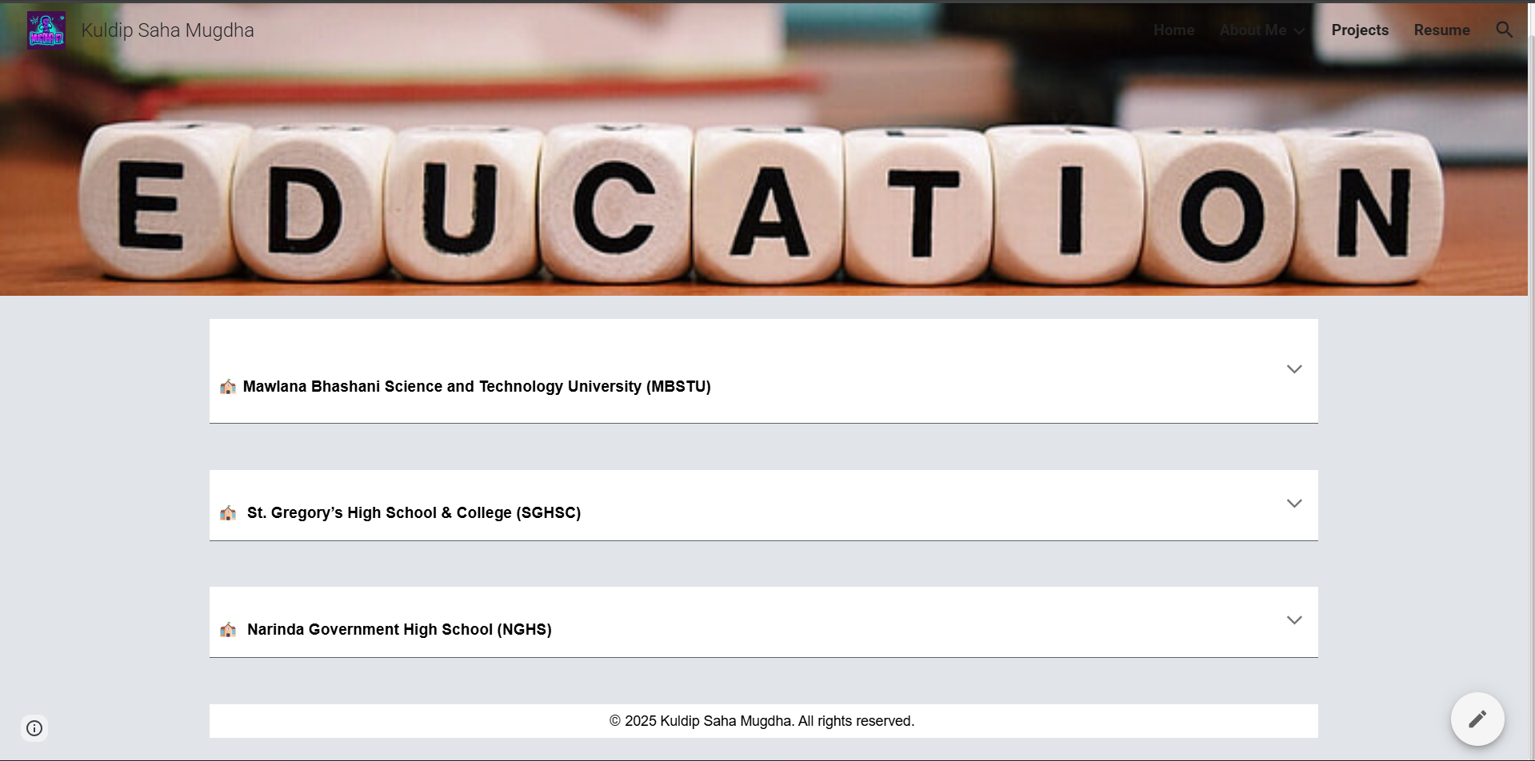
Fig 03: Education Section

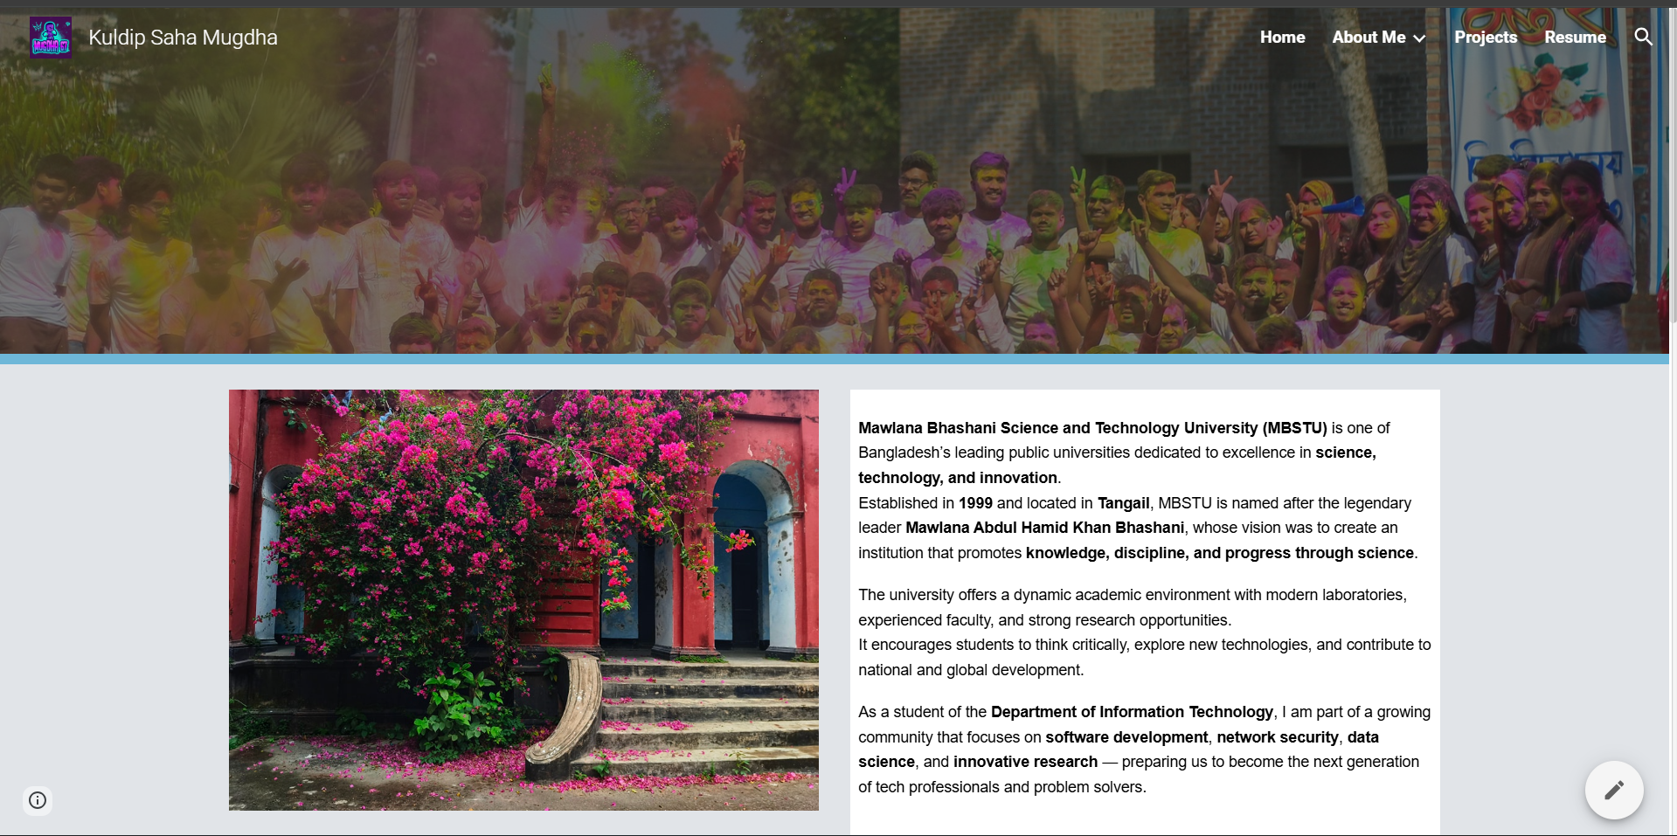
Fig 04: Education Gallery Section
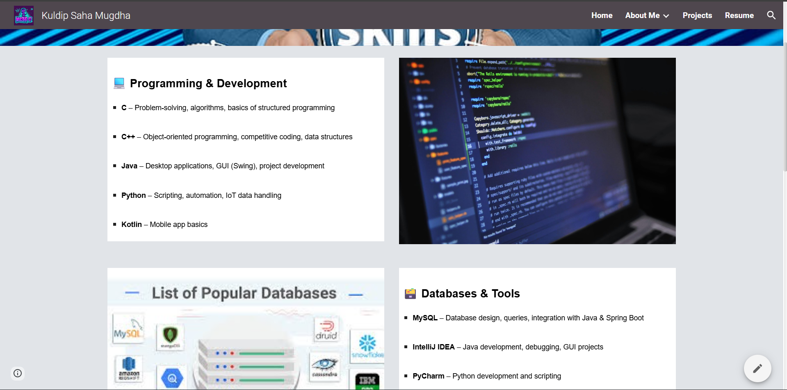
Fig 05: Skills Section

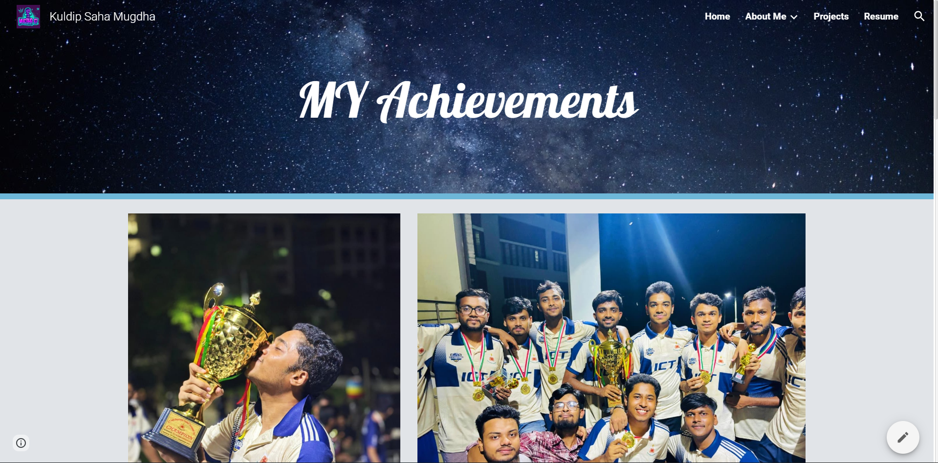
Fig 06: Achievements Section

- Developing the “Projects” Page:
In this page , I included detailed descriptions of the projects I have worked on. Each project was explained with its objective, tools used, and results, making it easy for
visitors to understand the scope and impact of my work.
➢ Visual Overview of the “Projects” Page:
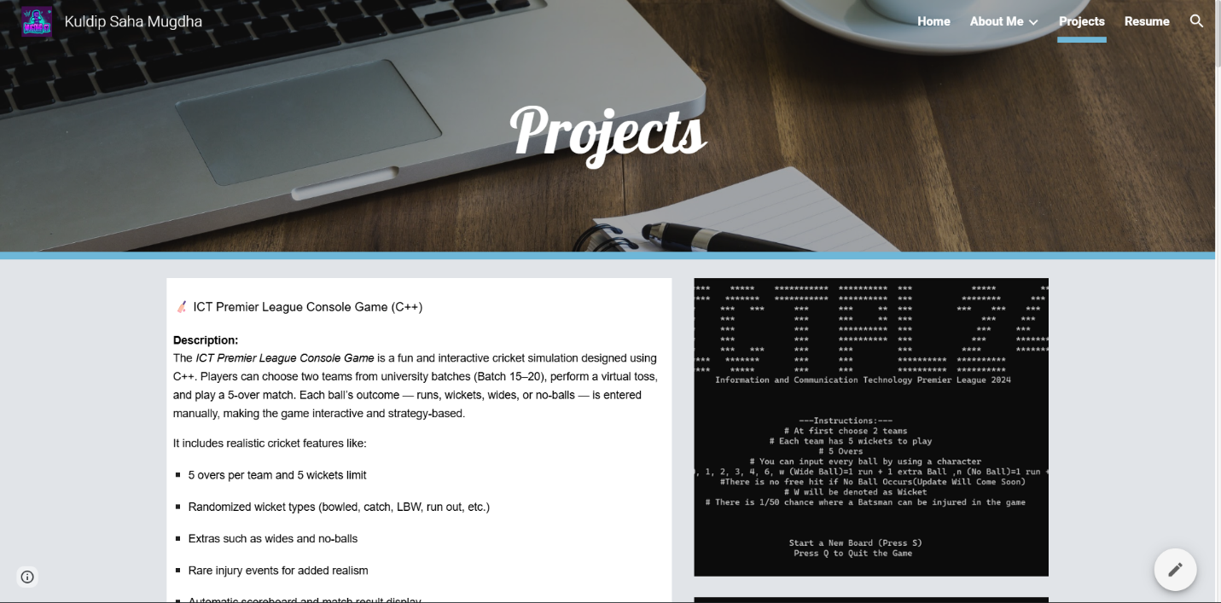

Fig 07: Projects Section
- Developing the “Resume” Page:
I uploaded a PDF version of my updated resume using Google Drive. The file was embedded directly on the page for easy viewing and downloading.
➢ Visual Overview of the “Resume” Page:
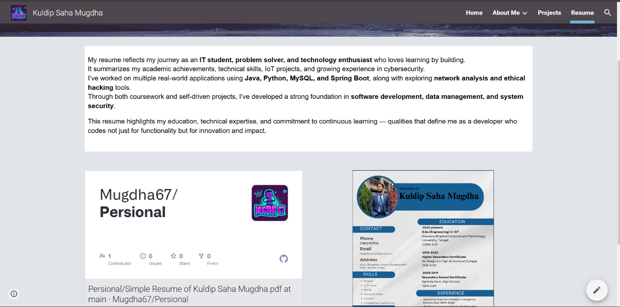

Fig 08: Resume Section
- Developing the “Contact” Page:
In this section, I added my contacts to be connected.
➢ Visual Overview of the “Contact” Page:
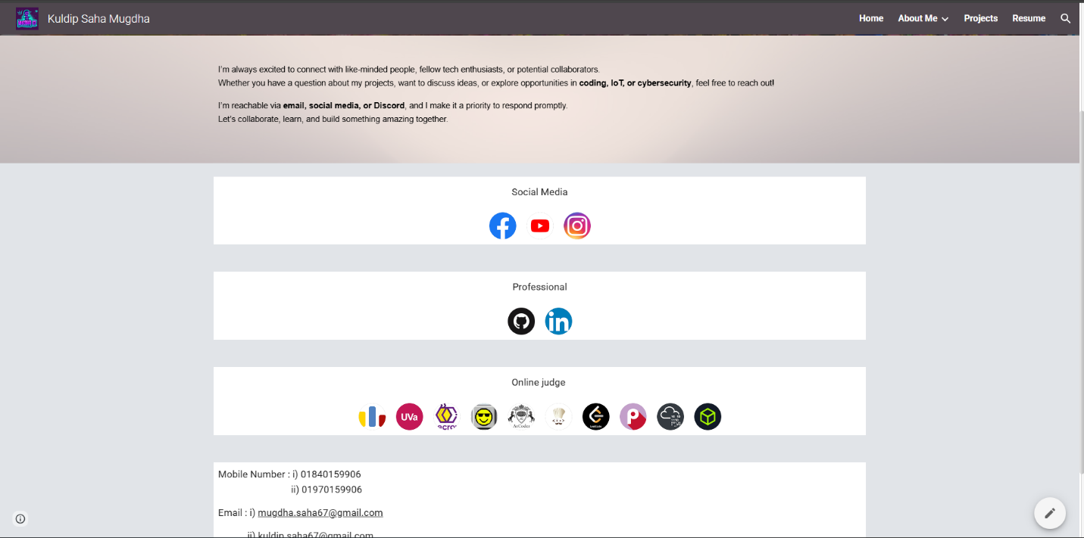

Fig 09: Contact Section

- Final Review & Publishing:
After all the sections were completed, I reviewed the site on both desktop and mobile to ensure readability and responsiveness. Once satisfied, I published the site and made it accessible via a shareable link.
Conclusion:
Creating my personal portfolio using Google Sites was a valuable and creative experience. It allowed me to present my academic background, skills, and projects in a well-organized and professional format. Through this lab, I gained practical knowledge in web design, digital presentation, and content structuring skills that will benefit me in both academic and professional settings.

